**Wireframe Document**

**Amazon Sales and Revenue**

Homepage

As per the problem statement, we have divided analysis into three sections :

1. Sales Analysis

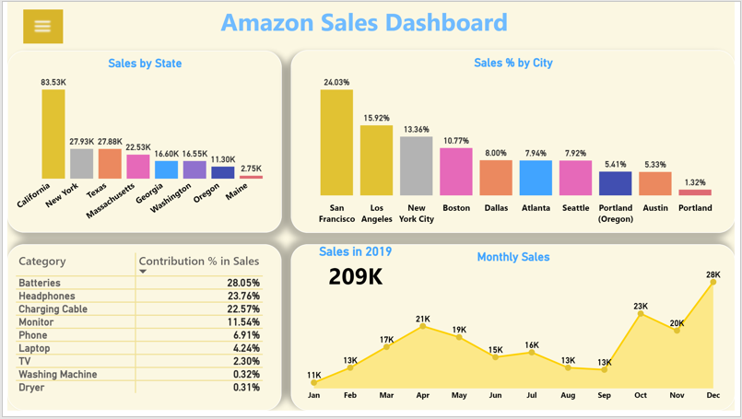

In this section we have created our first dashboard and tried to interpret following insights :

* **Sales Distribution between various states**



* **City’s Contribution in Sales ( in %) in Total Sales**



* **Product’s Category-wise distribution (in %) of Sales**



* **Monthly Sales figure and Total Sale in Year 2019**



1. Revenue Analysis

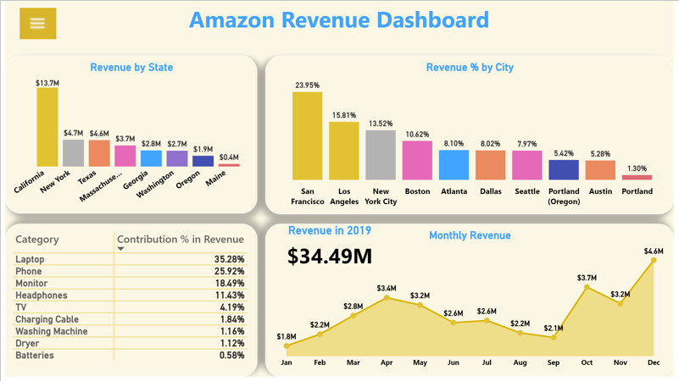

In this section we have designed our second dashboard and interpret the following insights :

* **Revenue Distribution between various states**



* **City’s Contribution in Revenue ( in %) in Total Sales**



* **Product’s Category-wise distribution (in %) of Revenue**



* **Monthly Revenue figure and Total Revenue in Year 2019**

